**Exporting from your Outlook Calendar into your Website Calendar**

**Open** your Calendar

**Click** the File tab

**Select** *Open* > *Import*

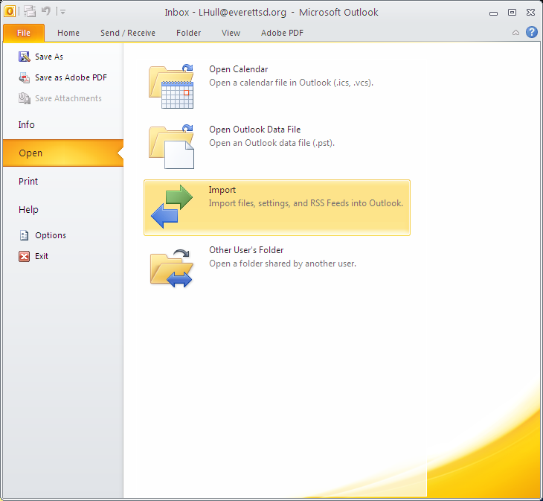

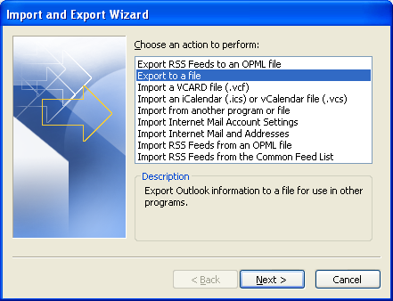

**Select** Export file

**Click** *Next*

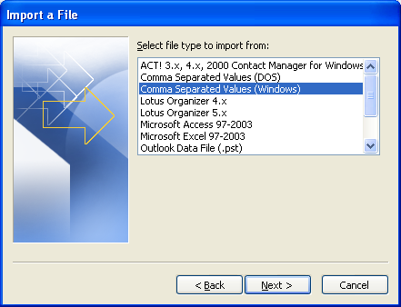

**Select** *Comma Separated Values*

**Click** *Next*

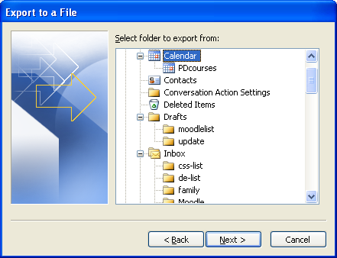

**Select** the Calendar you want to export

**Click** *Next*

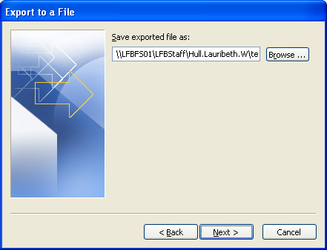

**Browse** to where you want to save the file and name it.

**Click** *Next*

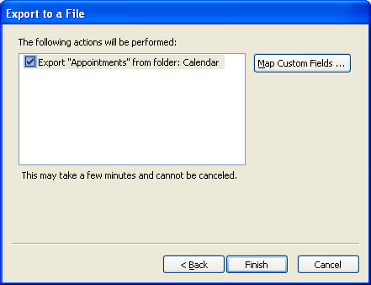

**Click** *Finish*

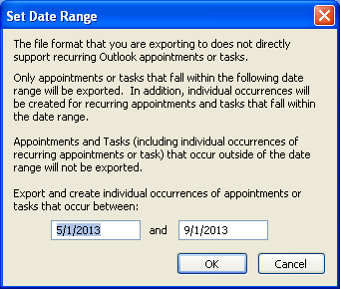

**Type** in the date range you want to export

**Click** *OK*

See how to import on next page.

**Go** to: Website editor (schoolwires)

**Open** you website calendar

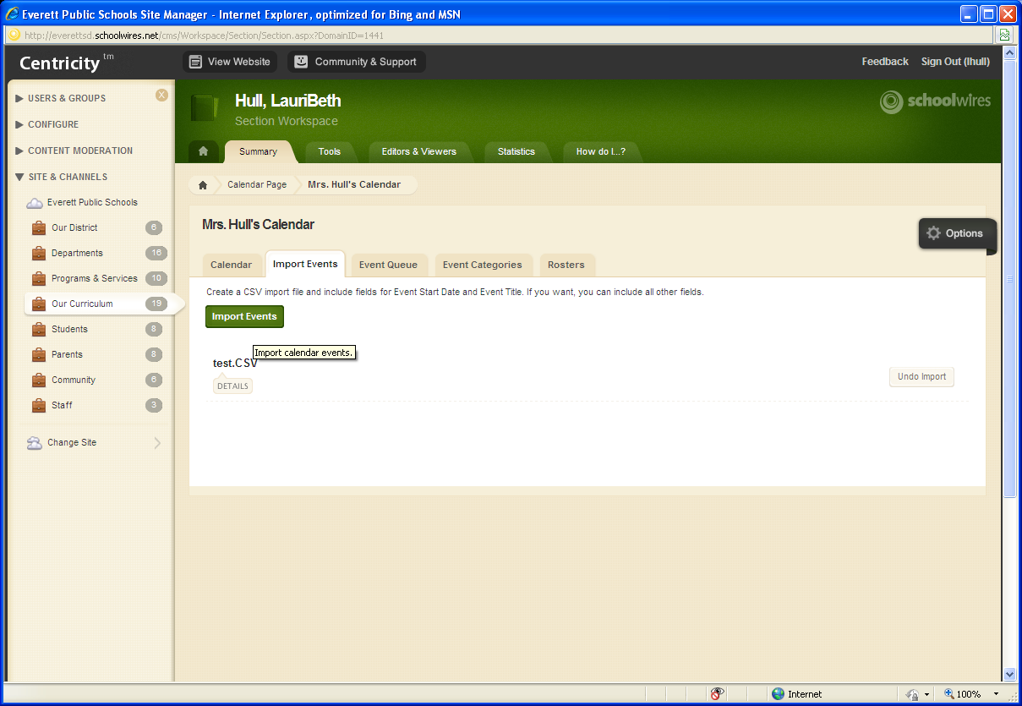

**Click** *Import* Events tab

**Click** *Import* Events button

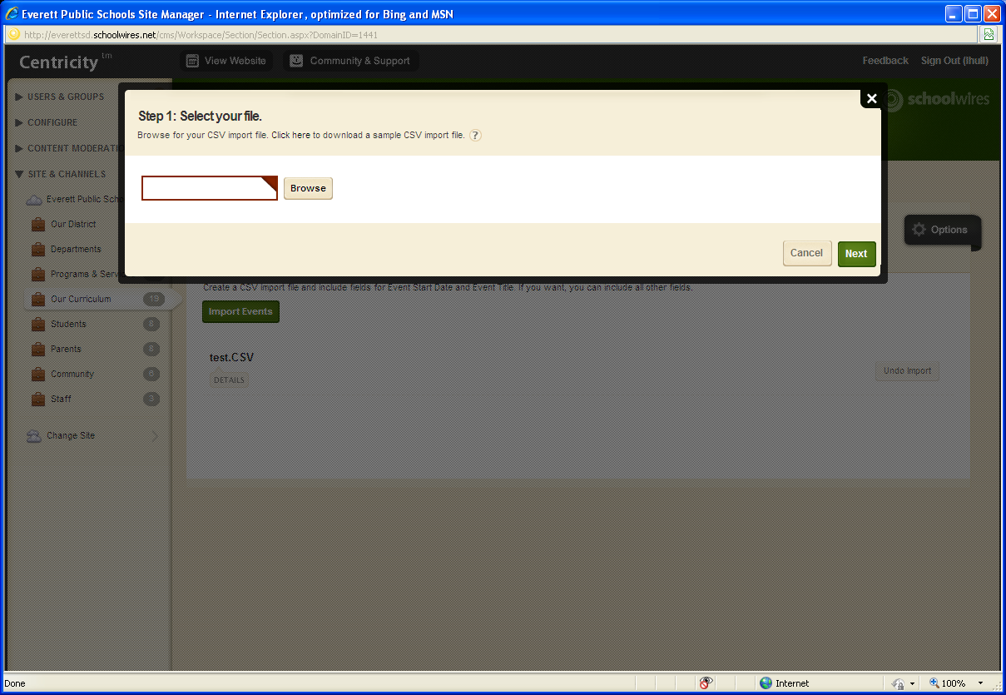

**Click** *Next*

**Click** *Browse* and find the file csv file you exported

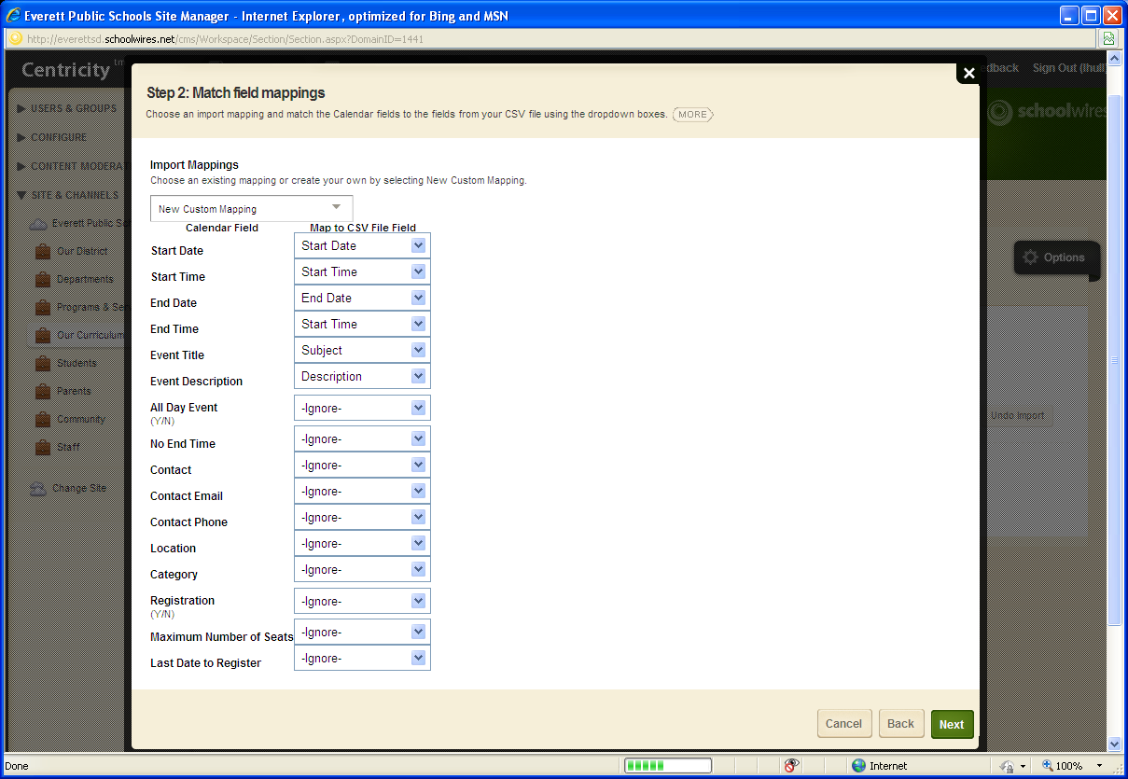

**Map** the Schoolwire calendar fields to the Outlook fields.

Minimum:

|  |  |
| --- | --- |
| **Schoolwires**  Start Date  Start time  End Date  End Time  Event Title  Event Description  All Day Event | **Outlook**  Start Date  Start time  End Date  End Time  Subject  Description  All day event |

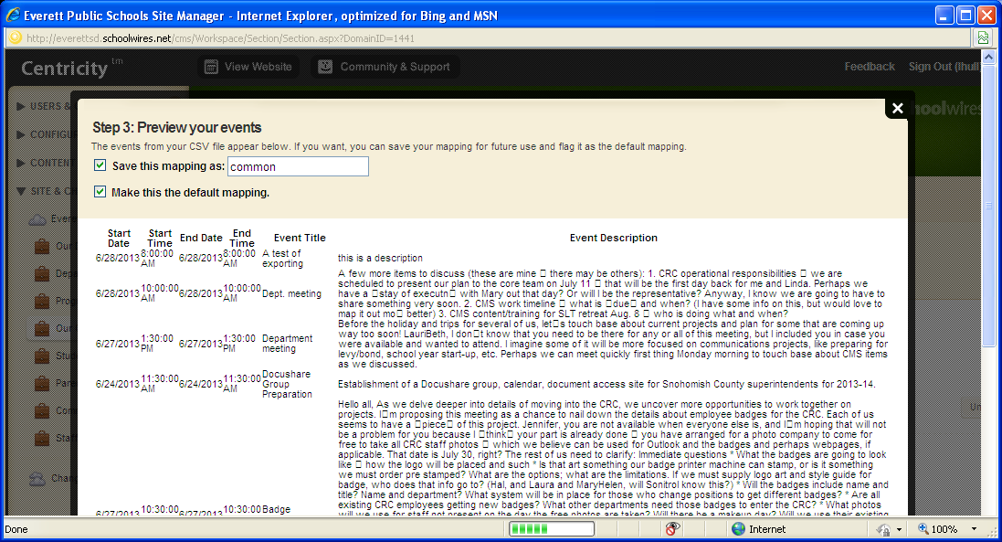

**Save** mapping as common

**Select** *Make this the default mapping*

This saves you from having to map every time you import.

IF needed you can change the mapping when you import

**Click** *Next* at bottom of the window

The events will show to everyone unless you assign specific viewers. **Click** *Import*

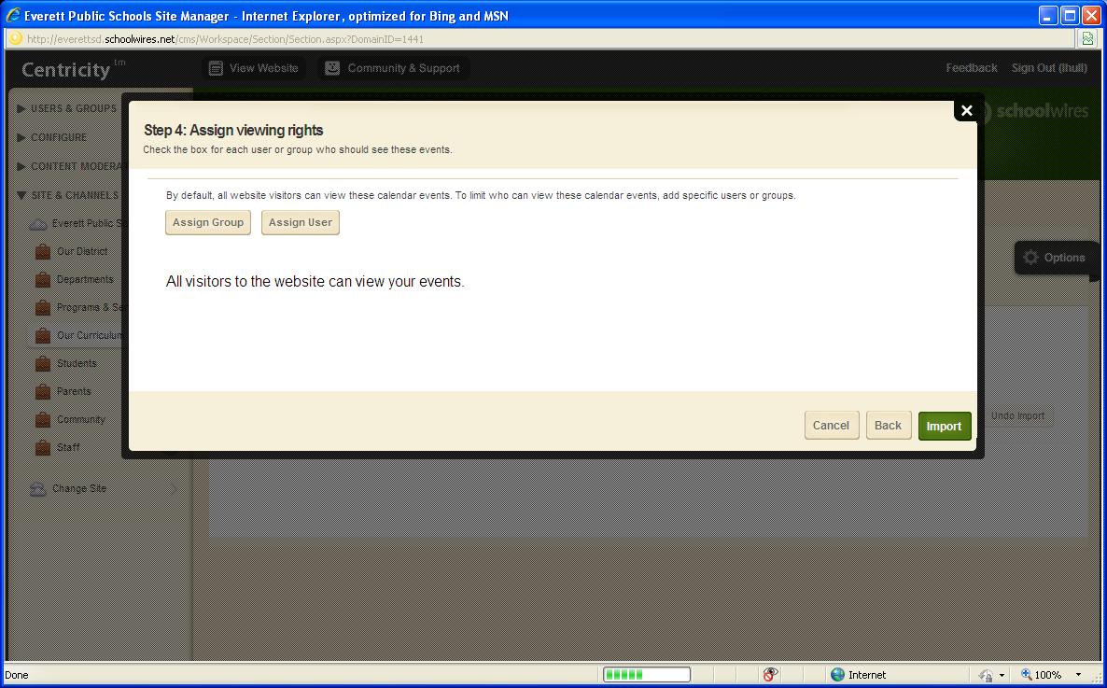

Events will now show in your website calendar

